**INtroduction to ai robotics**

**Name: Girish S Roll No: AM.EN.U4AIE22044**

# **Labsheet – 5**

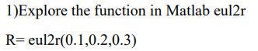

**% Q1**

**R = eul2r(0.1,0.2,0.3)**

**trplot(R, 'color', 'r');**

**view(3);**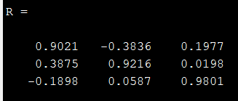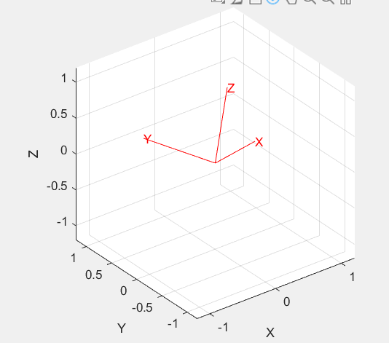

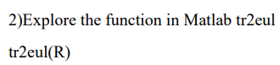

**% Q2**

**EulAngles = tr2eul(R)**

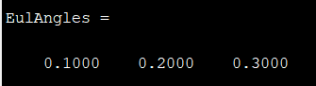



**% Q3**

**inverse = inv(R)**

**transpose = R'**

**For Orthogonal Matrices, it follows the property**

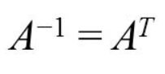

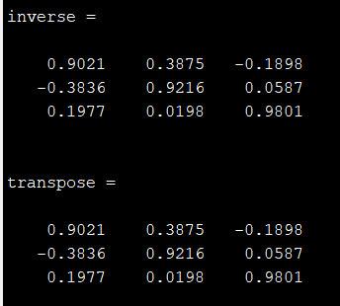

**R-1 = RT**

**Thus R is Orthogonal**

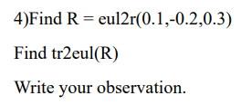

**% Q4**

**R = eul2r(0.1,-0.2,0.3)**

**EulAngles = tr2eul(R)**

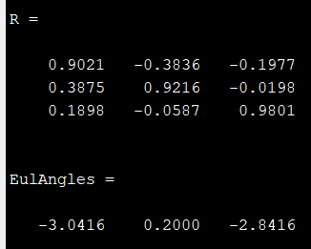

**Euler Angles is a conversion of Quaternions. Transforms use Quaternions under the functions eul2r(phi, theta, psi) and tr2eul(R).**

**Quaternions are functions of sines and cosines, which are periodical.  
Thus the Quaternion conversion results in the range of [0, 2π]  
if an input other than in the range of [0, 2π] is given the conversion back to Eulerian Angles will result in the domain of Quaternion, Thus Quaternion conversion will not result in the same Eulerian Angle**